**Name:- Dharan Gowda Superset id:-6387532**

**Exercise 1: Configuring a Basic Spring Application**

**Scenario:**

Your company is developing a web application for managing a library. You need to use the Spring Framework to handle the backend operations.

**Solution:-**

1. **Set Up a Spring Project:**
   * Create a Maven project named **LibraryManagement**.
   * Add Spring Core dependencies in the **pom.xml** file.

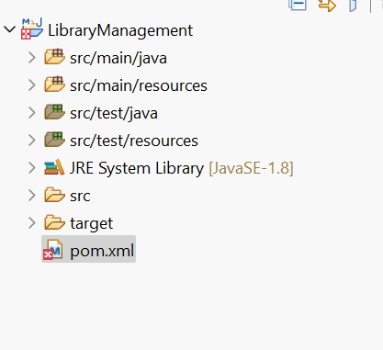

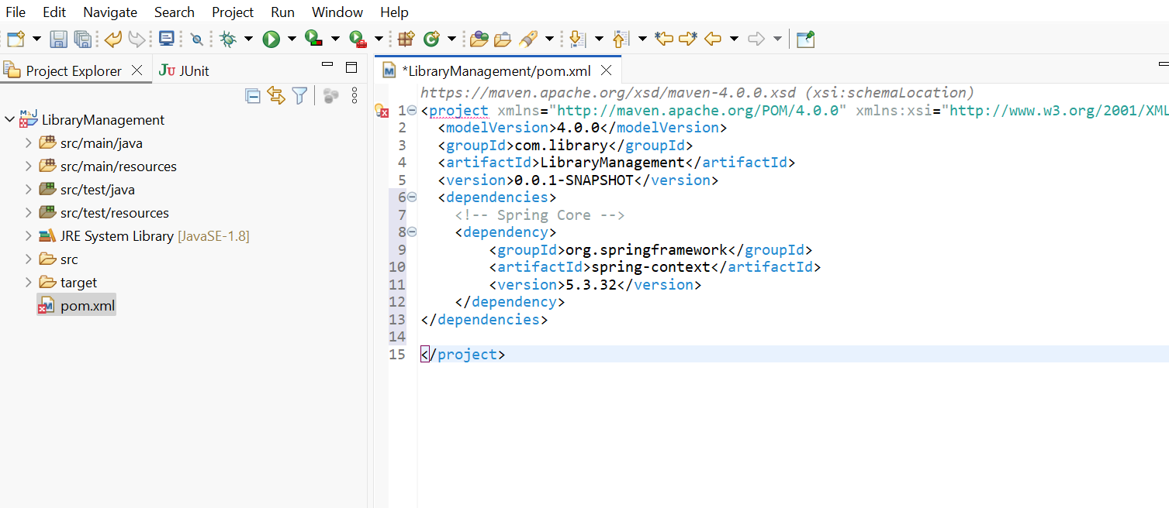

**2. Configure the Application Context:**

* + Create an XML configuration file named **applicationContext.xml** in the **src/main/resources** directory.
  + Define beans for **BookService** and **BookRepository** in the XML file.

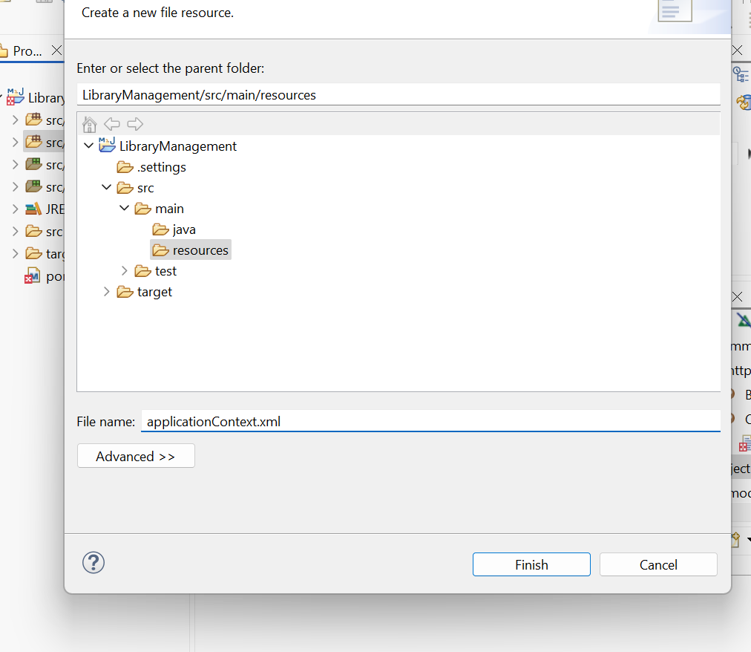

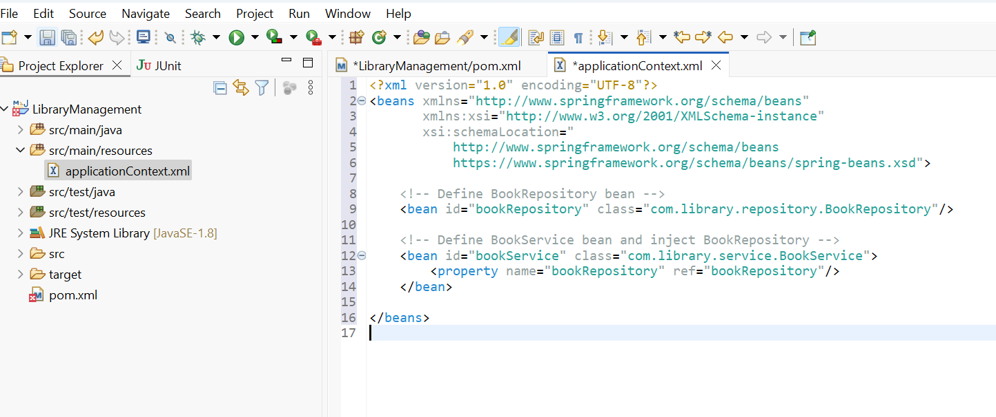

**3. Define Service and Repository Classes:**

* + Create a package **com.library.service** and add a class **BookService**.
  + Create a package **com.library.repository** and add a class **BookRepository**

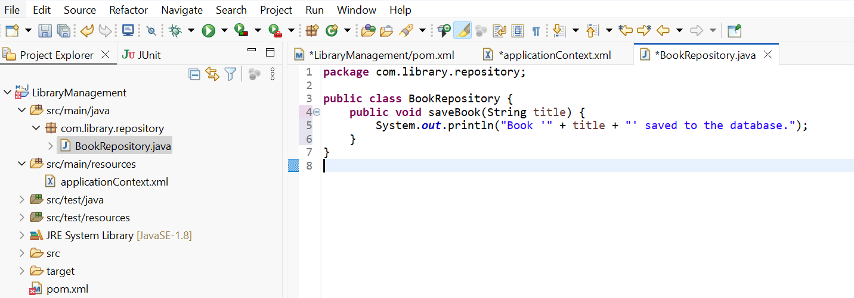

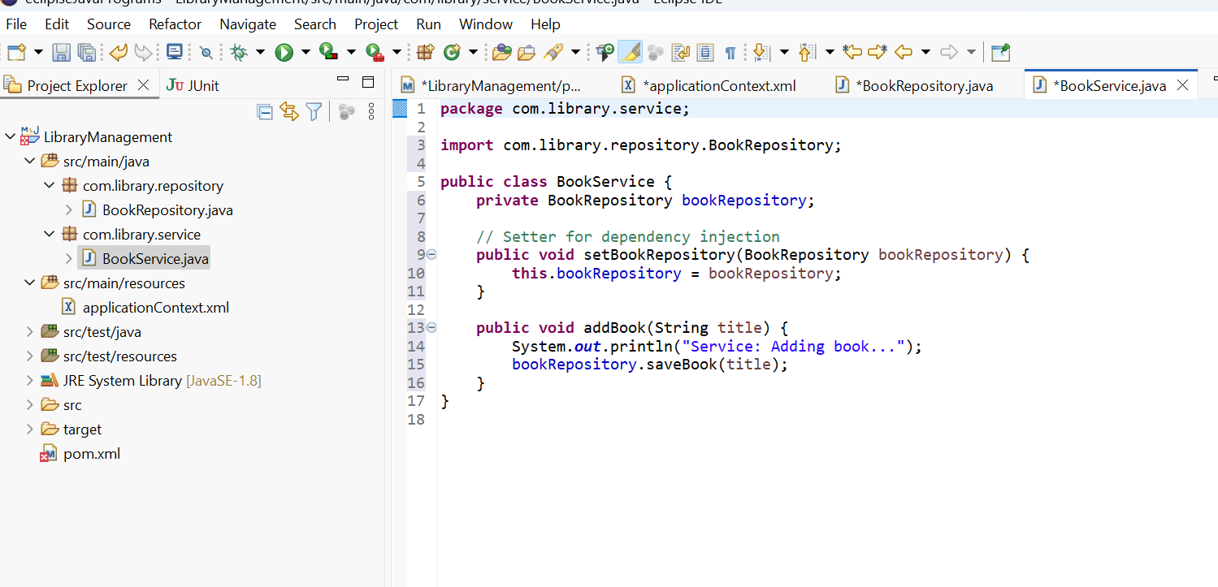.

1. **Run the Application:**
   * Create a main class to load the Spring context and test the configuration.

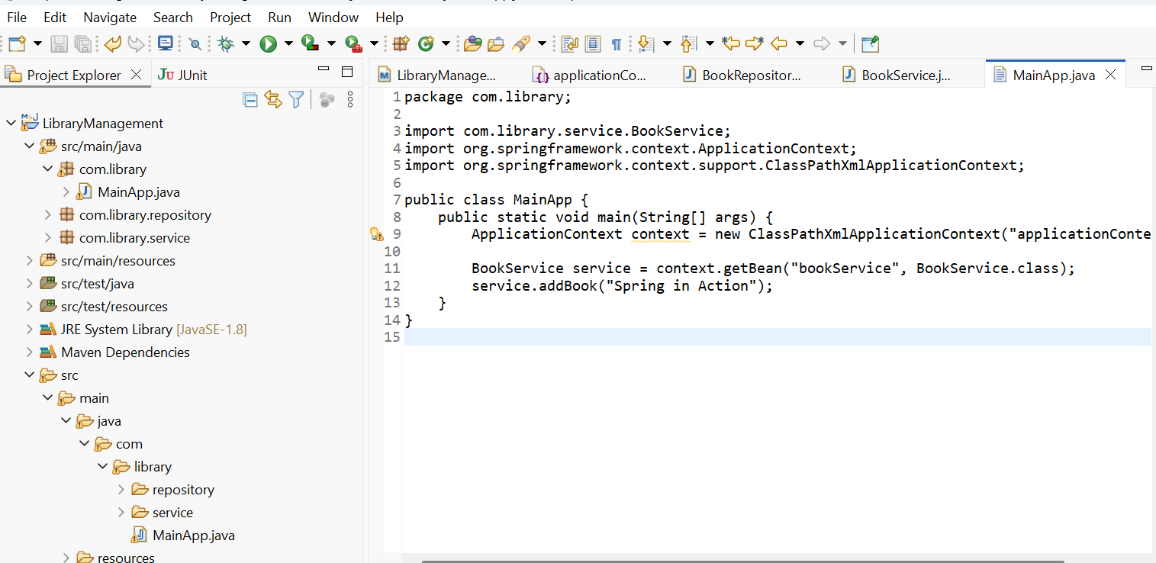

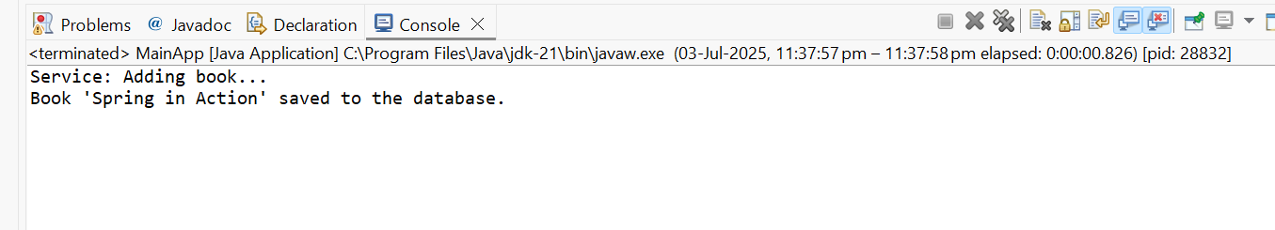

**Exercise 2: Implementing Dependency Injection**

**Scenario:**

In the library management application, you need to manage the dependencies between the BookService and BookRepository classes using Spring's IoC and DI.

1. **Modify the XML Configuration:**

Update **applicationContext.xml** to wire **BookRepository** into **BookService**

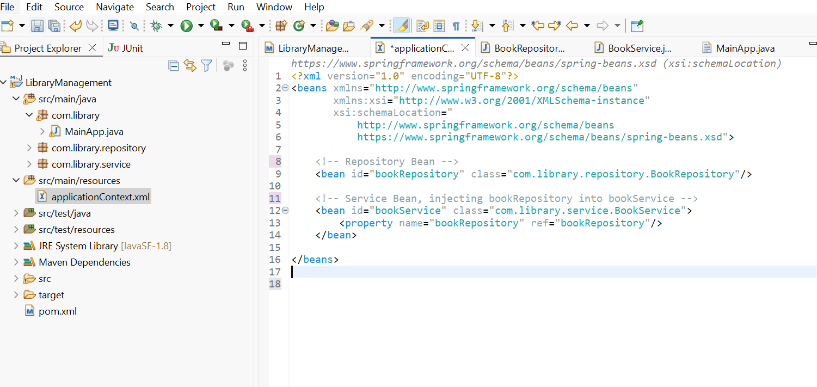

1. **Update the BookService Class:**

Ensure that **BookService** class has a setter method for **BookRepository**

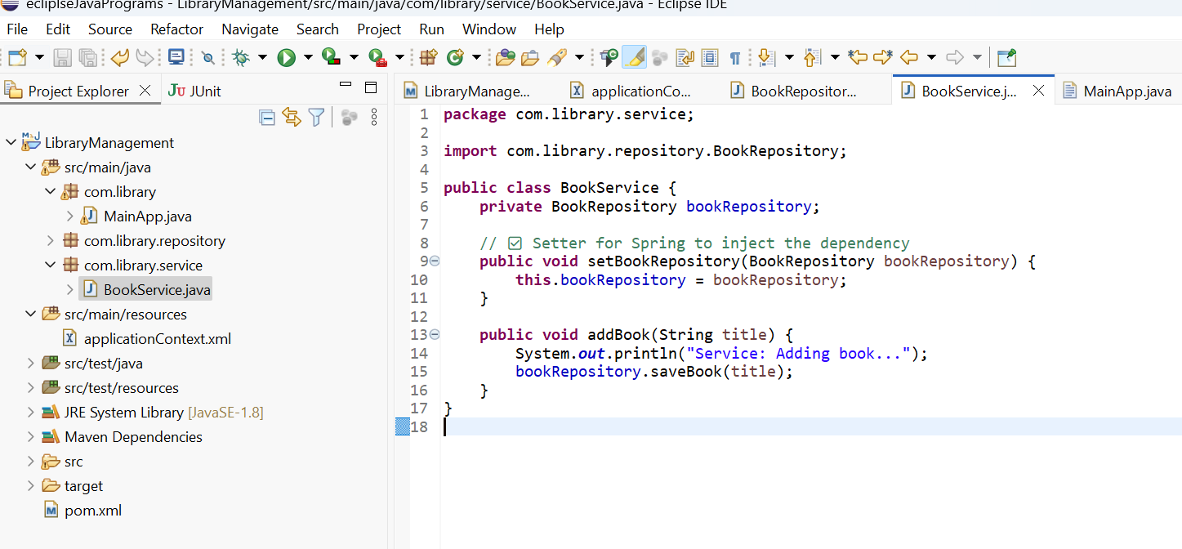

1. **Test the Configuration:**

Run the **LibraryManagementApplication** main class to verify the dependency injection

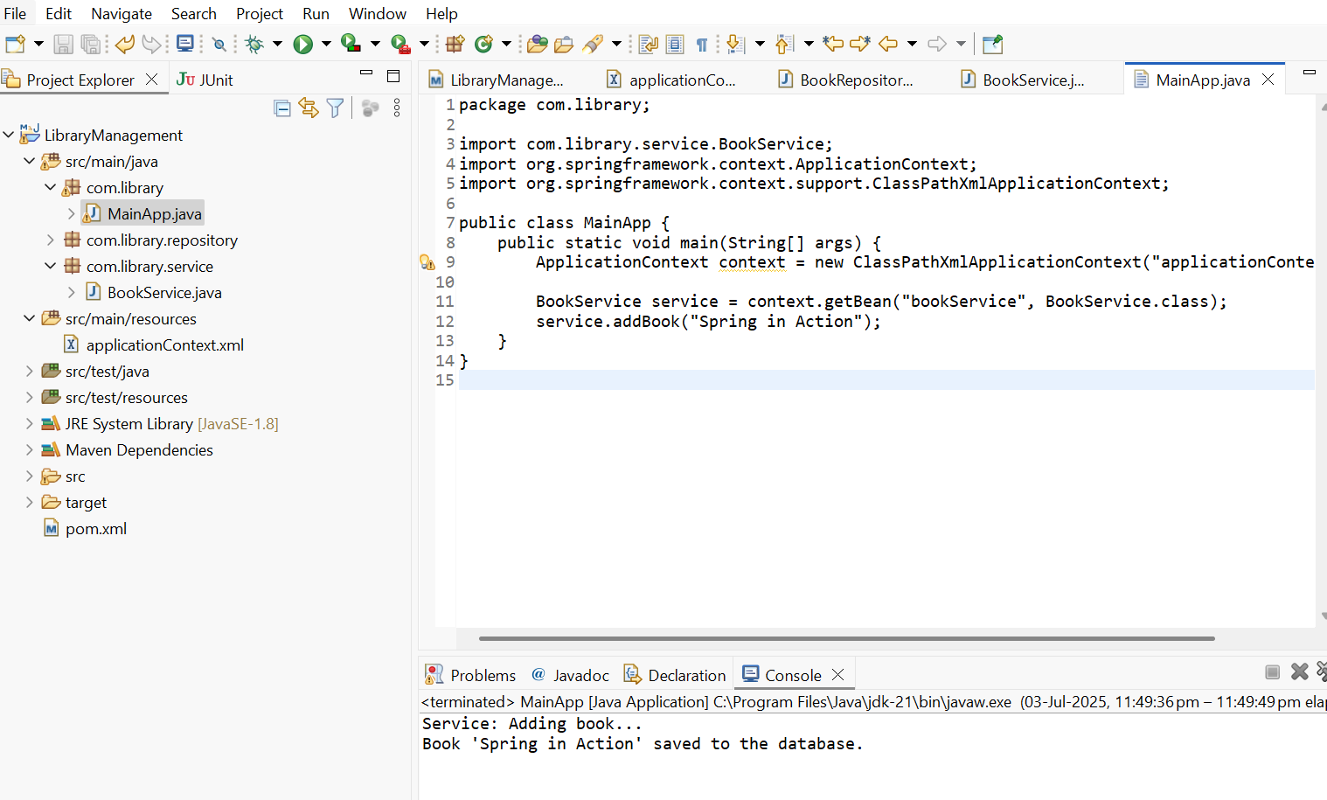

**Exercise 4: Creating and Configuring a Maven Project**

**Scenario:** You need to set up a new Maven project for the library management application and add Spring dependencies.

1. **Create a New Maven Project:**

Create a new Maven project named **LibraryManagement**

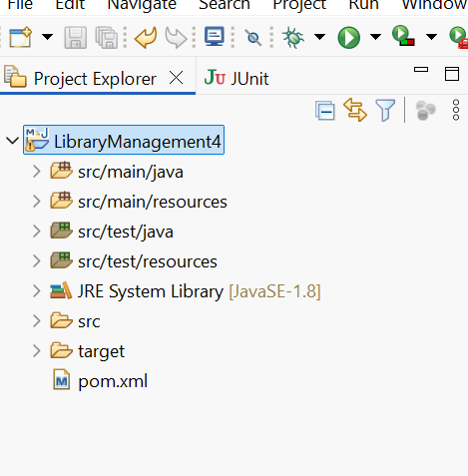

1. **Add Spring Dependencies in pom.xml:**
   * Include dependencies for Spring Context, Spring AOP, and Spring WebMVC.

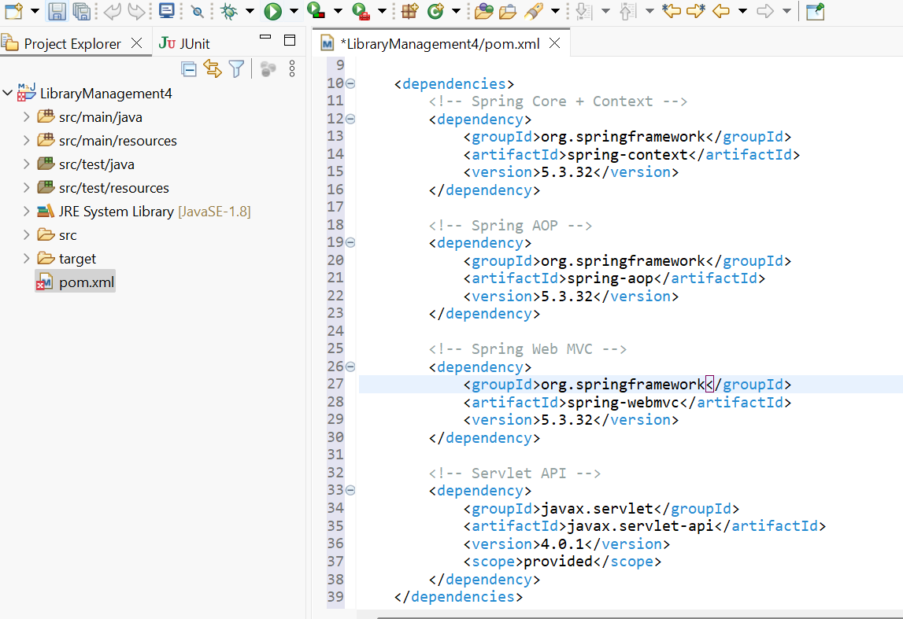

1. **Configure Maven Plugins:**
   * Configure the Maven Compiler Plugin for Java version 1.8 in the pom.xml file.

